

Human Biology ATAR – Task 8: Test
DNA ad Cell division (6%)
Name: MARKING KEY
Time allowed: 60 Minutes
Section | Your Mark | Marks available | Percentage of Investigation
Multiple Choice (A) |  | 20 | 40%
Short Answer (B) |  | 40 | 60%
 |  | 60 | 100%

Declaration of Authenticity
I (Student Name) _____________________ declare that this work is my own and I have not plagiarised from any source.

Signature:
Date:

Section A – Multiple Choice (20 marks)
Answer all questions by clearly circling the letter ONLY. Use only a BLUE or BLACK pen. If you make a mistake, place a CROSS through the letter; do not erase or use correction fluid, and circle your new answer. Marks will not be deducted for incorrect answers. No marks will be given if more than one answer is completed for any question.

- During mitosis, there are several clearly visible stages. During which stage do the spindle fibres pull the new chromosomes to opposite poles of the cell?

- Interphase
- Prophase
- Metaphase
- Anaphase

- How many haploid cells are produced in the first meiotic division of meiosis?

- 1
- 2
- 3
- 4

- Differentiation is best described as:

- Different characteristics appearing in organisms
- A permanent change in the genome of individuals
- The process by which specialised cells develop special characteristics
- The process by which organs become specialised for specific functions

- Which of the following is the start codon?

- AUC
- ATG
- AGU
- AUG

- In DNA replication:
- DNA polymerase creating a new strand in a 5’ to 3’ direction
- DNA ligase creating a new strand in a 5’ to 3’ direction
- DNA polymerase creating a new strand in a 3’ to 5’ direction
- DNA primase creating a new strand in a 5’ to 3’ direction

- During cell division, the DNA molecule replicates itself. The reason for this is so:
- if the cell makes a mistake there is enough DNA to go around
- the daughter cells end up with the same genetic information as the parent cell
- the DNA can move out of the nucleus into the cytoplasm
- there are enough chromosomes for each cell produced

Question 7 – 8 refers to the following diagram:

- This process is called:

- Non-disjunction
- Crossing Over
- Random Assortment
- Random Fertilisation

- If this occurs in the first meiotic division of meiosis. How many chromosomes are found in each daughter cell?

- Two daughter cells with 4 chromosomes, two daughter cells with 2 chromosomes
- Two daughter cells with 2 chromosomes, two daughter cells with no chromosomes
- Four daughter cells with 1 chromosomes in each
- Two daughter cells with 1 chromosomes, two daughter cells with 2 chromosomes

- Which of the following is NOT a property of cancer cells?

- Can metastasise
- Cannot differentiate
- Undergo Apoptosis
- Do not communicate with other cells

- Where does transcription take place:

- Mitochondria
- Cytoplasm
- Nucleus
- Endoplasmic reticulum

- If an individual has trisomy 21 this means:

- They have one less chromosome 21
- They have one extra chromosome 21
- They have no chromosome 21
- They are missing part of chromosome 21

- Which of the following statements about epigenetics is correct?

- Acetylation is when acetyl groups are added to histone proteins, enhancing gene expression.
- Acetylation is when acetyl groups are added to histone proteins, inhibiting gene expression.
- Methylation is when methyl groups are added to the CpG sites on the DNA molecule to enhance gene expression.
- Methylation is when methyl groups are added to CpG sites on the histones to inhibit gene expression.

- During which of the following stages of the mitotic cycle can the arrangement of chromosomes at the equator of the spindle be observed at a cell?

- Prophase
- Telophase
- Anaphase
- Metaphase

- Where in human cells is DNA located?

- In the nucleus.
- In the nucleus and in the mitochondria.
- In the nucleus and in the ribosomes.
- In the nucleus and in the Golgi body.

- A DNA molecule is bound to special proteins that assist them coil into a smaller area. These proteins

- Nucleotides
- Chromatin
- Genes
- Histones

- Messenger RNA leaves the nucleus and attaches to a

- Ribosome
- Golgi apparatus
- Mitochondrion
- Cell membrane

- Which of the following is in the correct order for the main stages of mitosis?

- prophase, metaphase, anaphase then telophase.
- metaphase, prophase, anaphase then telophase
- prophase, anaphase, metaphase then telophase
- prophase, metaphase, telophase then anaphase

- In a DNA molecule, adenine pairs with

- adenine.
- guanine.
- thymine.
- uracil.

- The chemical element that is found in all amino acids but is not found in either carbohydrates or lipids is

- carbon.
- oxygen
- nitrogen.
- hydrogen.

- Anticodons pair with

- amino acids.
- mRNA codons.
- DNA codons.
- ribosomes.

END OF MULTIPLE CHOICE

Section B – Short Answer
Answer all questions in the spaces provided. Use only BLUE or BLACK pen.

- One in every two Australians will be diagnosed with cancer before the age of 85 (7 marks)

- What is the difference between a malignant and a benign tumour? (1 mark)
Malignant tumours – Tumour cells are able to spread to other parts of the body
Benign tumours – tumour cells are not able to spread to other parts of the body

- State two common carcinogens: (2 marks)
Any two of the following:

- UV Radiation
- X-rays
- Ionising radiation
- Viruses
- Chemicals

- State three lifestyle changes that reduces risk of cancer: (3 marks)
Any three of the following:
- Do not smoke
- Slip, slop, slap
- Eat fruit and vegetables
- Consume only moderate amounts of alcohol
- Low fat diet
- Use protective clothing when dealing with carcinogens
- Avoid being overweight or obese

- What test is sent to Australians over the age of 50 to detect bowel cancer: (1 mark)

Faecal occult blood test

- The coding strand of a DNA molecule has the following sequence of bases: (5 marks)

DNA: T-A-C-T-T-A-G-C-T-C-G-G-C-A-T-A-C-C

- Write the codons for the messenger RNA molecule transcribed from this part of the DNA: (1 mark)

mRNA: AUG-AAU-CGA-GCC-GUA-UGG

- Write the sequence of anticodons of the transfer RNA molecules that match each of the codons in part (a). (1 mark)

tRNA: UAC-UUA-GCU-CGG-CAU-ACC

- Using the chart below to write the sequence of amino acids that the DNA strand codes for. (1 mark)

Protein: Met/start-Asn-Arg-Ala-Val-Trp

- Explain the difference between the coding and template strand of the DNA molecule. (2 marks)

- Template strand – is the strand that is copied during protein synthesis to make mRNA
- Coding Strand – is not copied. Will have the same code as the mRNA strand.

- Below is a diagram of a small section of DNA (9 marks)
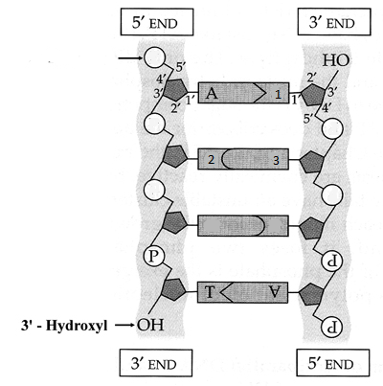

4

4

- Structure A is a nitrogen base called adenine. Name the nitrogen bases labelled 1, 2 & 3
(3 marks)

1 THYMINE – CYTOSINE – GUANINE

- Name the term used to describe structure 4 (indicated parts in the box) and identify the two other molecules (besides the nitrogen base) that make up this structure. (3 marks)
- NUCELOTIDE
- PHOSPHATE
- DEOXYRIBOSE

- Explain how the process of DNA replication allows daughter cells to receive DNA copies that are exactly the same as the parent cell’s DNA. (3 marks)
- Parent DNA is zipped open – weak bonds between bases
- each section has half the original information, and serves as a template
- base pairs can only attach to their matched base – A/T G/C
- hence new half which forms is identical to the original

- Describe two differences between DNA and mtDNA: (2 marks)
 | DNA | mtDNA
Where is it found in the cell? | Nucleus | Mitochondria
How is it stored? | DNA strands are bound to histone proteins. | As circular molecules not attached to proteins.

- Meiosis is an important type of cell division for the human body. (12 marks)

- What type of cells does meiosis produce? (1 mark)
Gametes/ova-sperm

Identify the stages of meiosis shown below then describe what happens at that stage.
The parent cell that is undergoing division has four chromosomes.
(6 marks)
Image | Stage of Meiosis | Description
 | Anaphase I | Homologous chromosomes are pulled to opposite poles of the cell by the spindle/mitotic fibres.
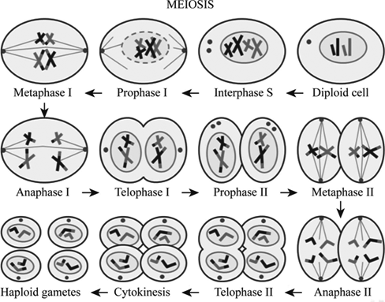 | Metaphase II | Chromosomes line up along the mid-line of the cell, mitotic/spindle fibres attach to the centromeres.
 | Telophase II | Chromosomes uncoil and a new nuclear membrane forms.

- For the parent cell that divided above how many daughter cells were produced?
(1 mark)
FOUR

- Were the daughter cells haploid or diploid?
(1 mark)
HAPLOID

- Before cell division begins interphase occurs. This is made up of three phases. Name them and describe what happens at each stage: (3 marks)

- G1 (First growth phase) – New proteins, growth and continues normal function.
- S Phase (Synthesis Phase) – DNA replication occurs.
- G2 (second growth phase) – New proteins and growth.

- Compare and contrast [3 differences/similarities between] RNA and DNA. Fill in the table below.
(3 marks)

Characteristic | DNA | RNA
bases | A T C G | A U C G – uracil replaces thymine
location in cell | nucleus and mitochondria | cytoplasm, nucleus, mitochondria
types of | nuclear DNA  mitochondrial DNA | messenger RNA  transfer RNA

- Explain why the process of mitosis is essential to growth in organisms (e.g. Humans) (2 marks)
- produces 2 identical cells from one
- hence organism increases in size

END OF TEST

